**ACTIVITY 1: CREATE PROGRAM TABLE**

Open Service now.

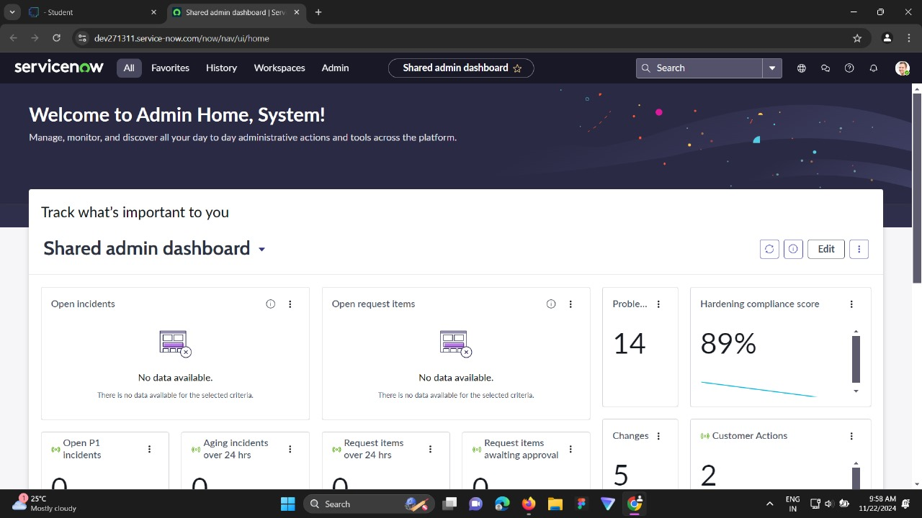

Click on All >> tables >> new.

Enter label name as “program”.

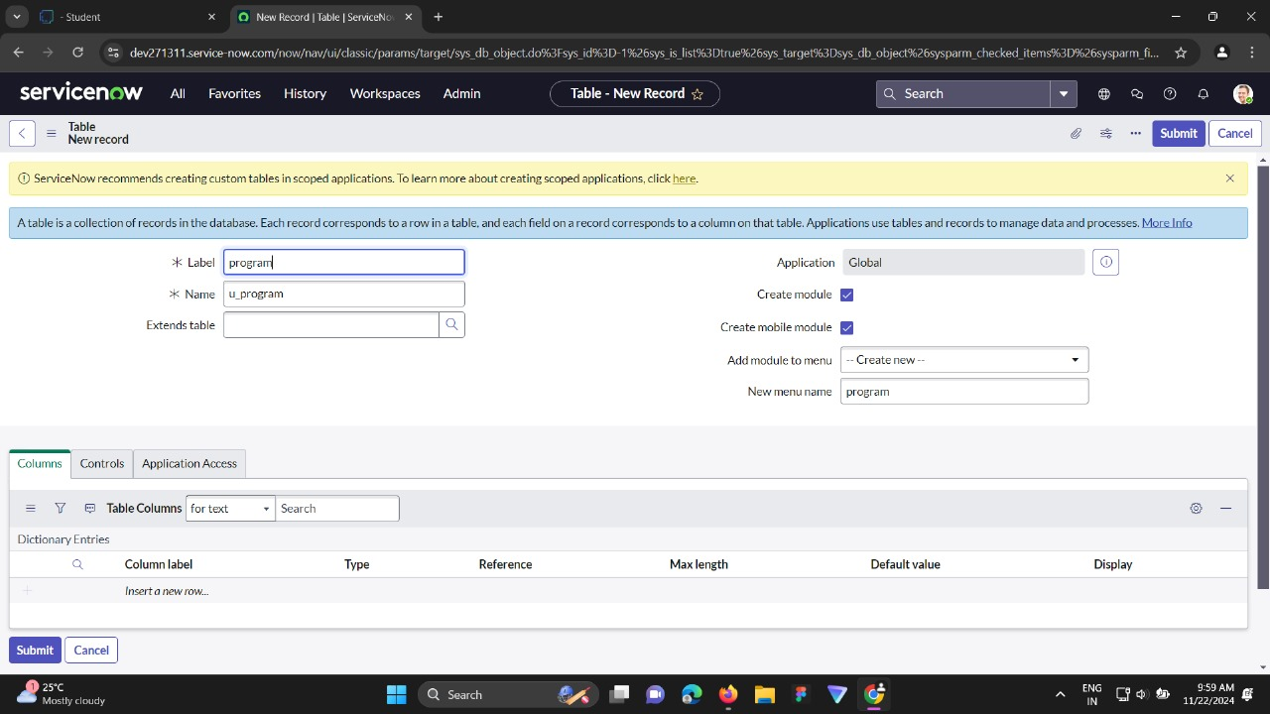

Add fields to the program table.

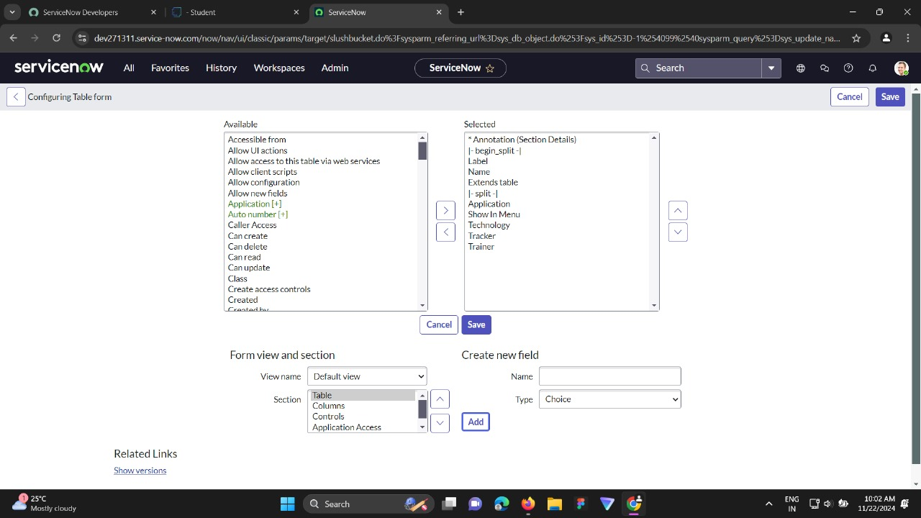

Add choices to the technology field.

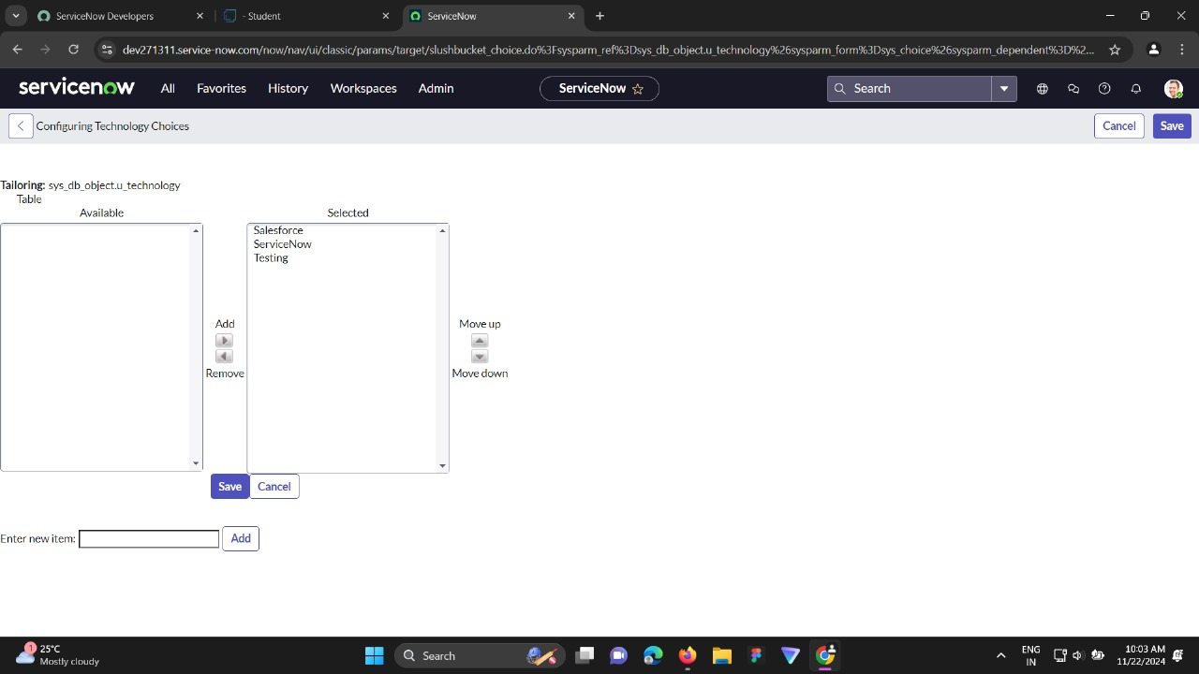

Add choices to the tracker field.

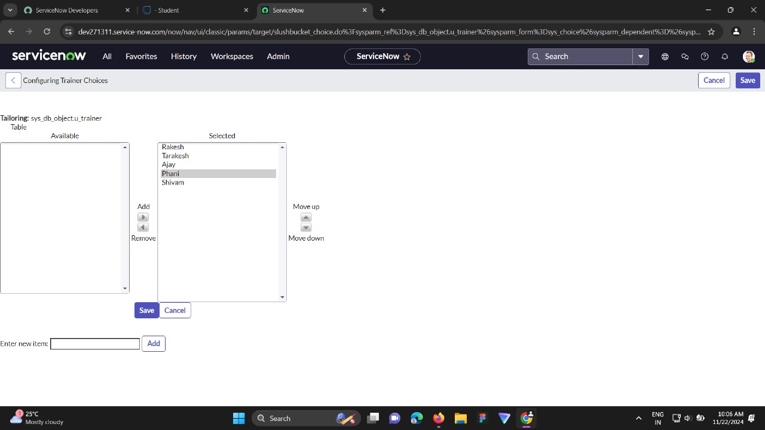

Add choices to the trainer field.

